# Module 3 Assignment 1 GitHub link:

[**https://github.com/xeno1211/M3A1**](https://github.com/xeno1211/M3A1)

# Screenshots:

## Index.js

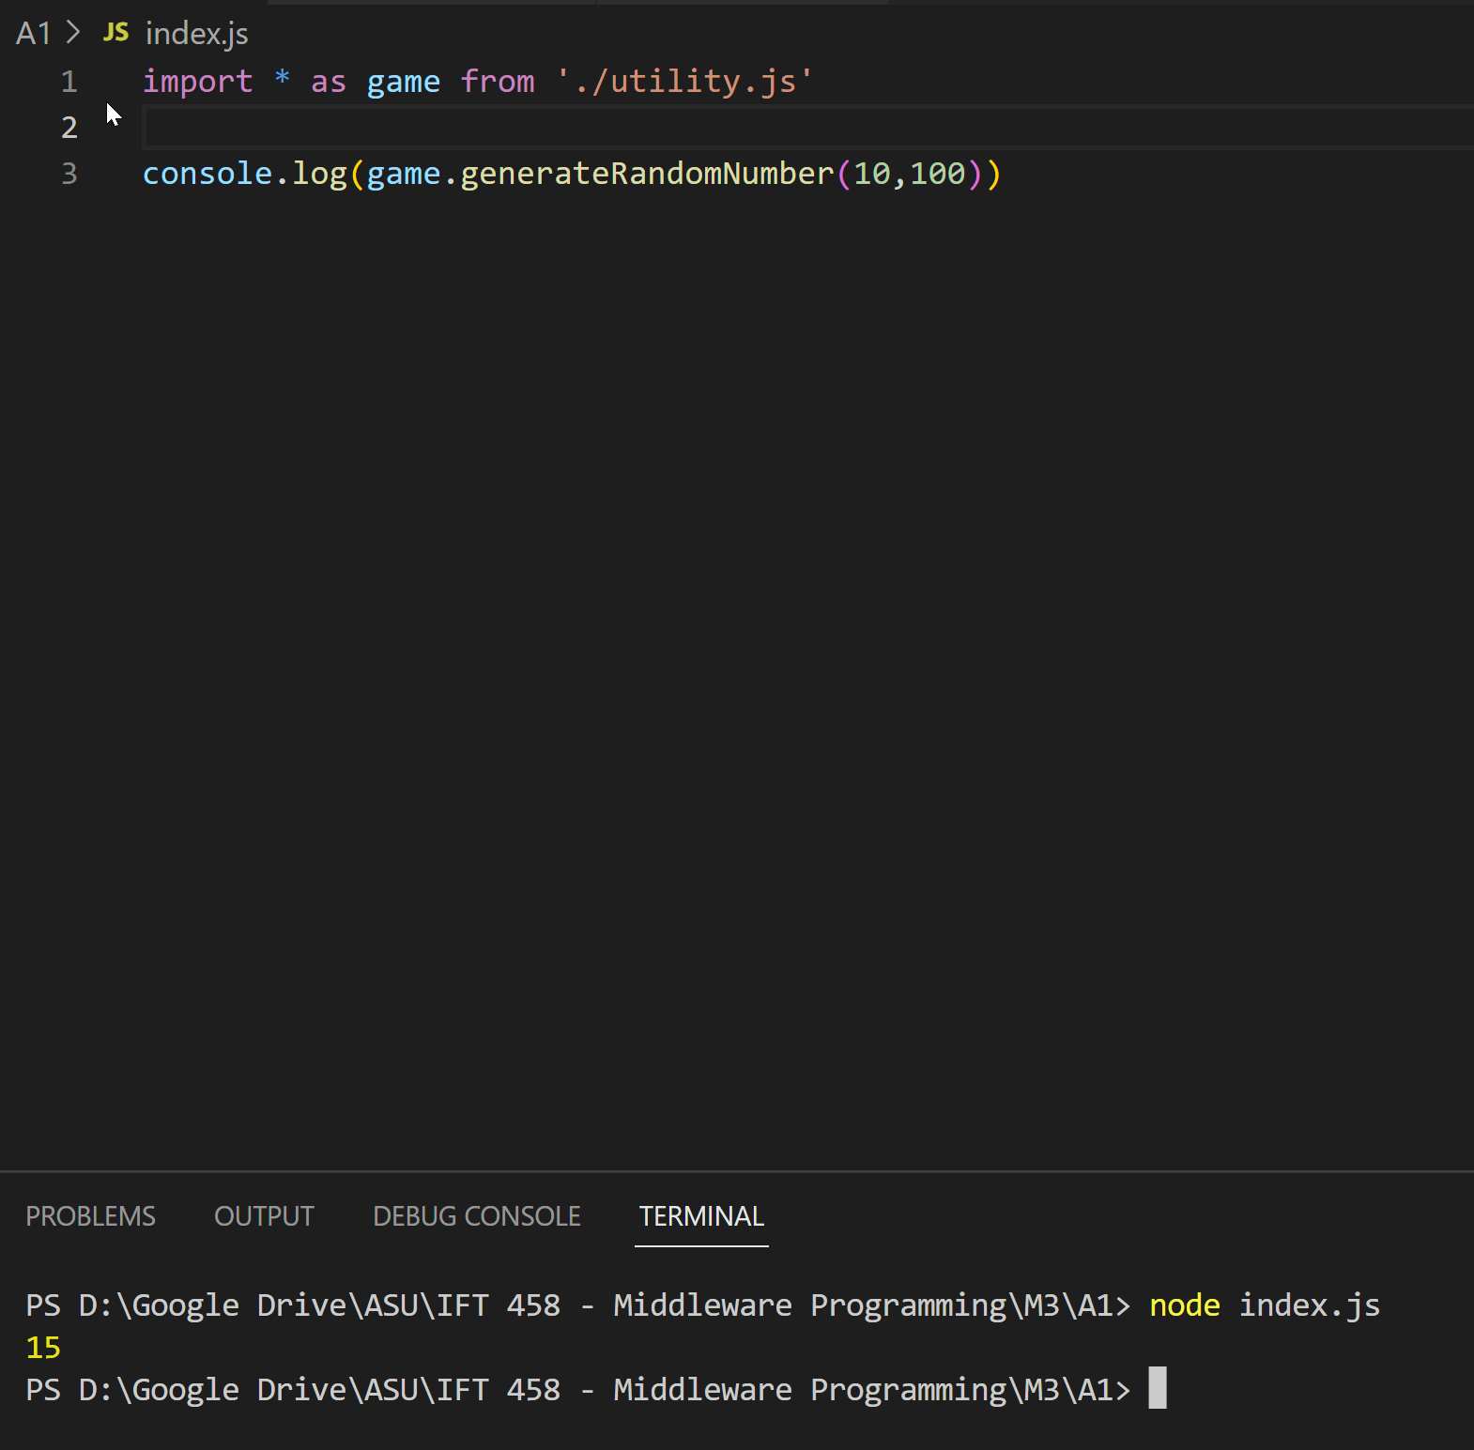

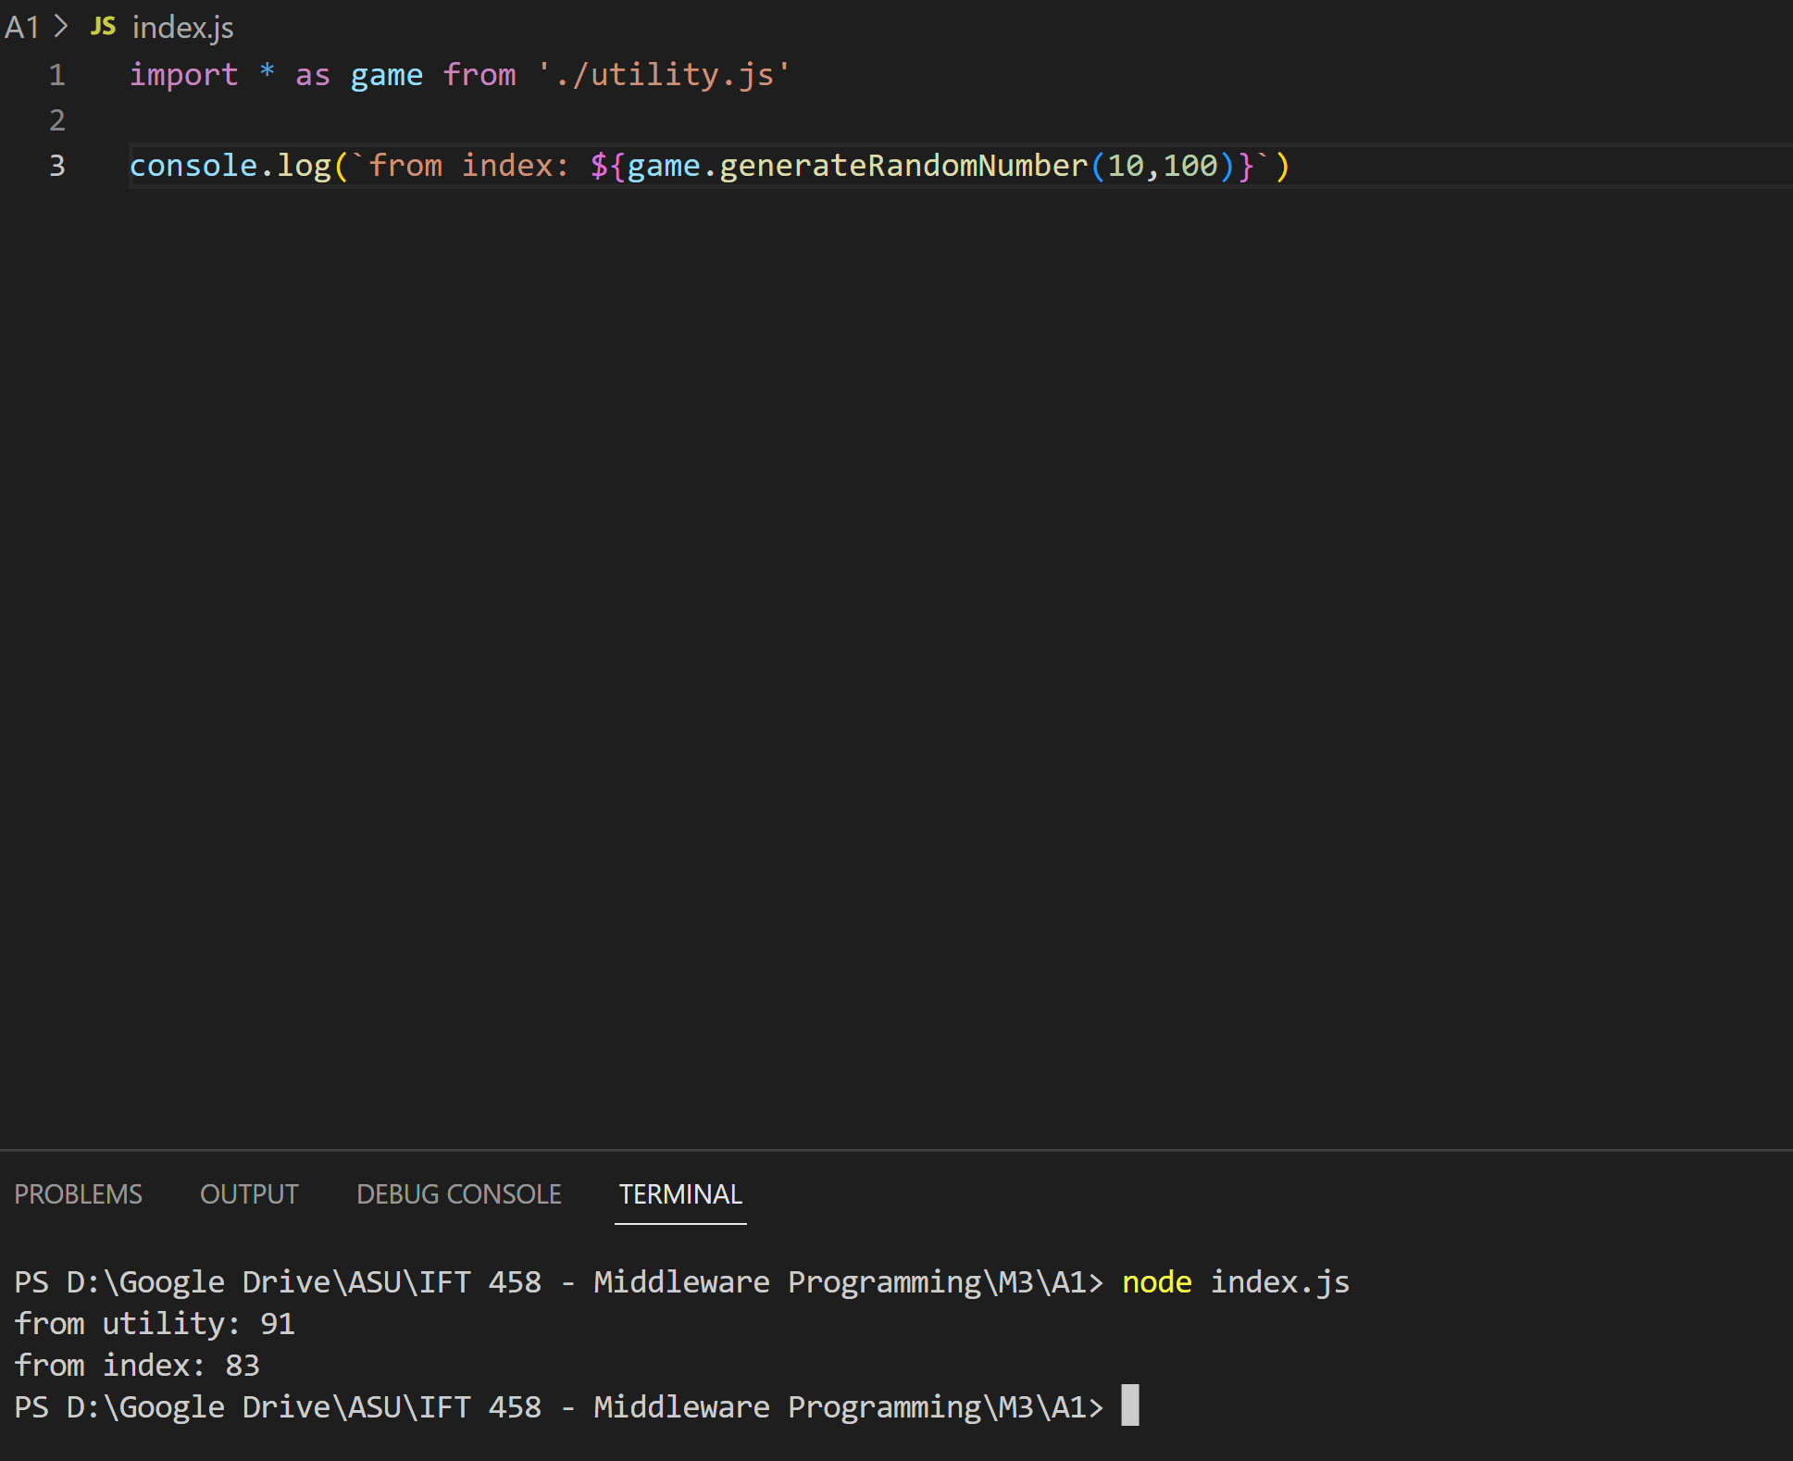

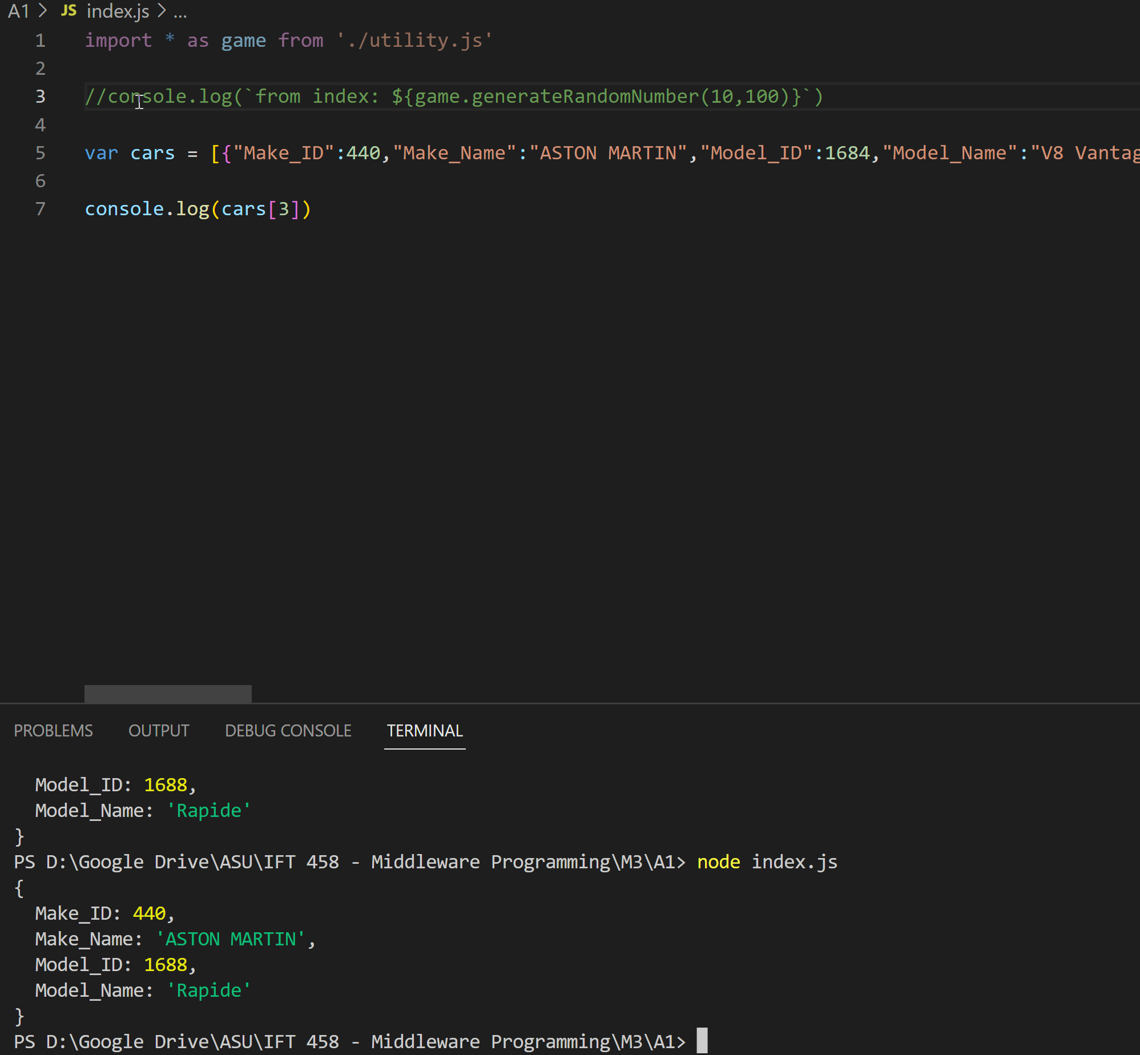

## Utility.js

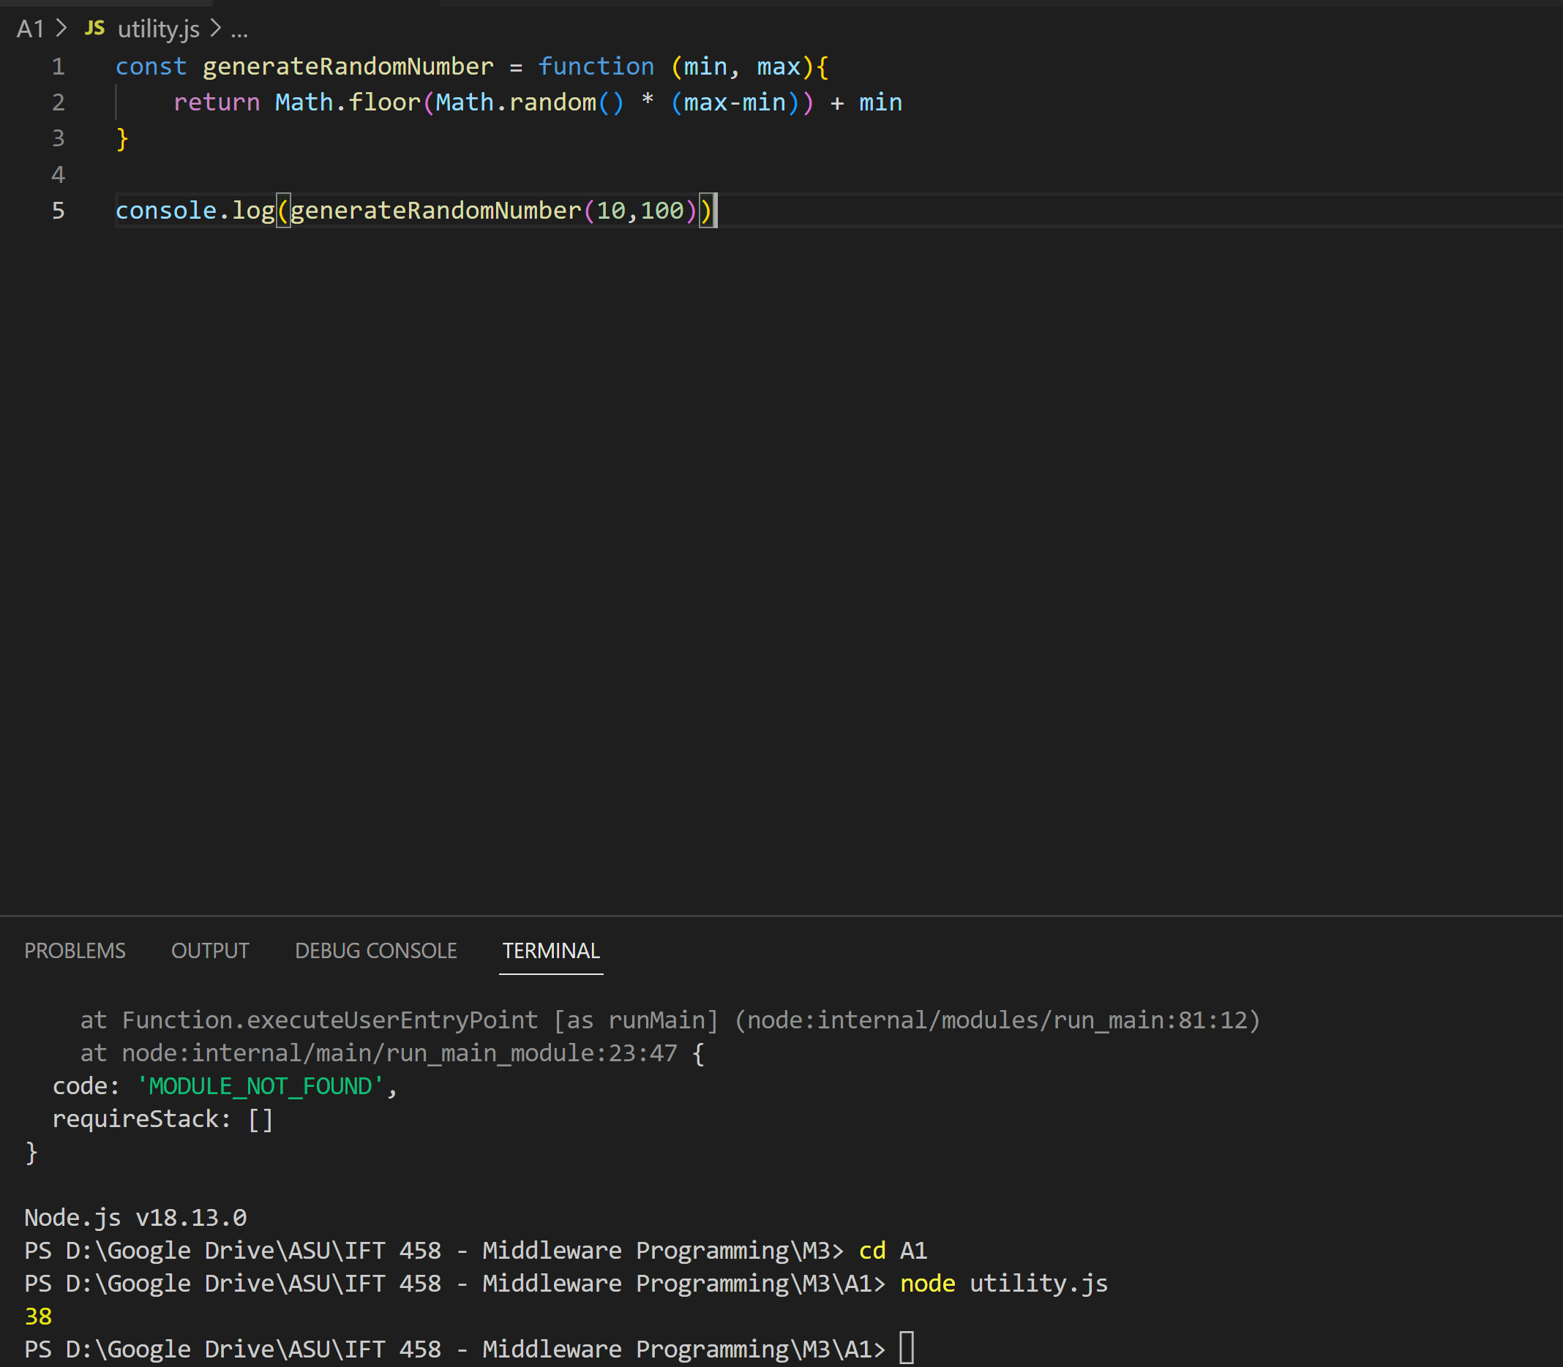

## DataImport.js

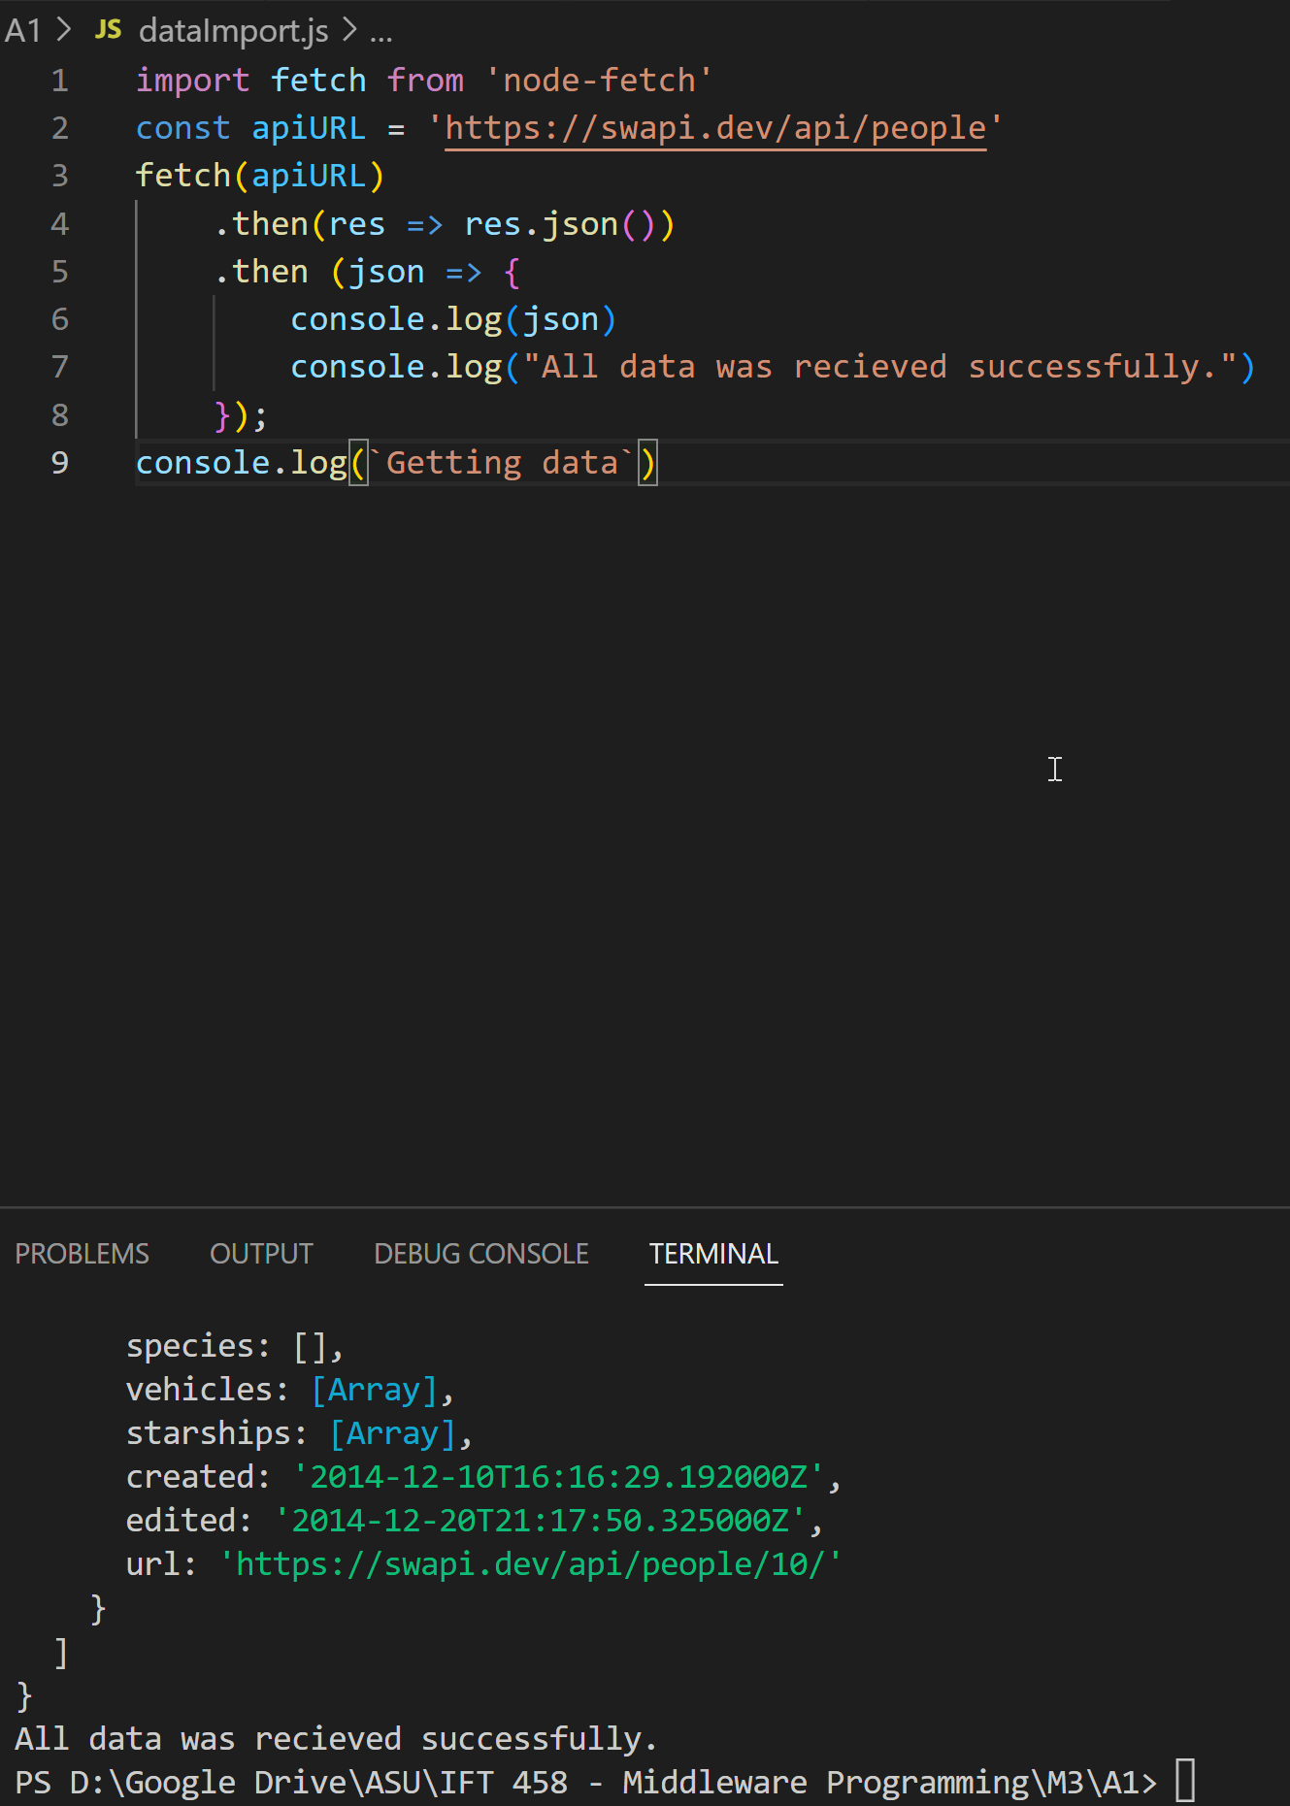

## contentNegotiation.js

